Naan Mudhalvan Phase 4 Assessment

Course Name : Internet Of Things

Project Title : Traffic Management System

Team Name is : Techtronz

Team Members :

|  |  |  |
| --- | --- | --- |
| Name | Register number | Naan Mudhalvan ID |
| Sanjesh R | 721221106089 | au721221106089 |
| Sivabalvigneshan P | 721221106097 | au721221106097 |
| Sri Krishnan N | 721221106103 | au721221106103 |
| Vishal S | 721221106120 | au721221106120 |

**Introduction:**

The provided code is a set of JavaScript files for a mobile application built using the React Native framework. React Native allows developers to create mobile apps for iOS and Android using JavaScript and React. The code consists of multiple components and screens that work together to create a simple mobile application. Let's briefly introduce each of the code files and their purposes with integrating the IoT.

**Objective:**

The objective of this code is to create a basic mobile application that includes the following key features:

* **Login Screen:**

Users can input their username and password. Upon clicking the "Login" button, the app verifies the credentials. If the credentials are correct, it navigates the user to the Home screen. Otherwise, it displays an error message.

* **Home Screen:**

This is the landing page of the application after a successful login. It displays a welcome message, buttons for accessing vehicle details, traffic condition information, and a logout button. Clicking on the "Vehicle" or "Traffic Alerts" buttons navigates the user to the respective screens. The "Logout" button allows the user to log out from the application.

* **Vehicle Details Screen**:

This screen displays information about a vehicle, including its name, driver name, speed, and destination place .The data is initially hardcoded but can be modified to fetch real-time information.

* **Traffic Condition Screen:**

This screen is designed to display traffic condition information .However, the implementation for fetching and displaying traffic condition data is left incomplete.

**Technology Stack:**

The provided code is a mobile application built using React Native, which is a popular framework for developing cross-platform mobile applications. Here is the technology stack used in this code:

* **React Native:** A JavaScript framework for building mobile applications for iOS and Android platforms. It allows for the development of native-like mobile apps using a single codebase.
* **JavaScript**: The primary programming language used for building the application's logic and functionality.
* **@react-navigation/native**: This library is used for handling navigation within the application. It provides a structured way to navigate between different screens and components.
* **@react-navigation/native-stack:** This library is used to create a stack-based navigation system, which is commonly used for mobile app navigation.

**Application Overview:**

The provided code is a basic mobile application that appears to be a prototype or starting point for a more feature-rich application. It consists of several screens and components, each serving a specific purpose.

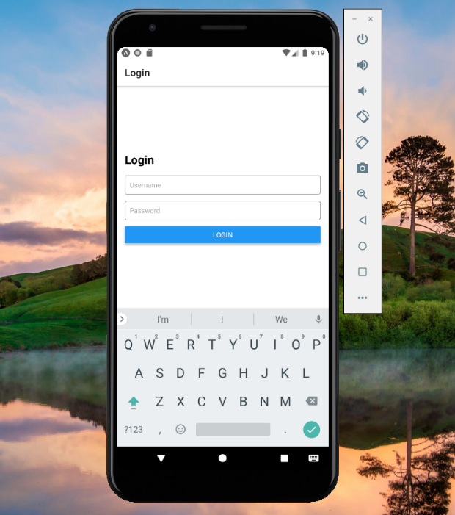

**LOGIN PAGE**

**Username :** iot

**Password :** 1234

**Login Screen (login.js) :**

* Objective: Allows users to log in to the application by entering their username and password.
* Technology: Text input fields for username and password, a "Login" button, and conditional navigation to the Home screen.
* Authentication: The user's input is validated, and upon successful login, the application navigates to the Home screen

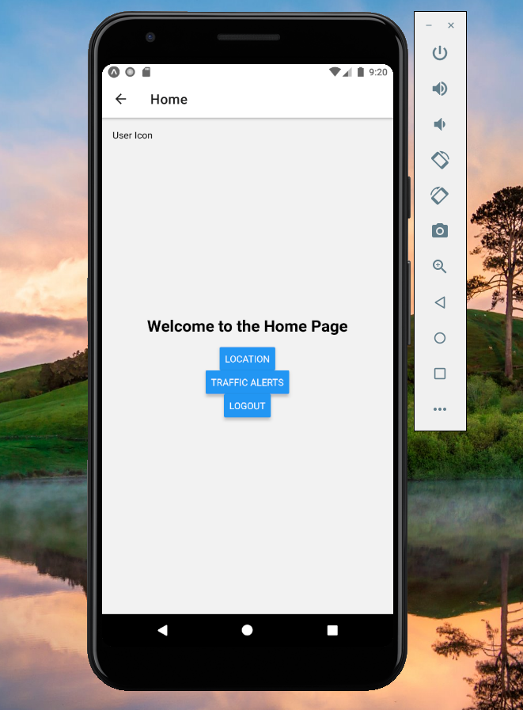

**HOME PAGE**

**Home Screen (Home.js):**

* Objective: Serves as the main screen after a successful login, welcoming the user and providing access to other features.
* Technology: It features buttons for accessing vehicle details, traffic condition information, and logging out.
* Navigation: Users can navigate to the Vehicle Details and Traffic Condition screens from here.

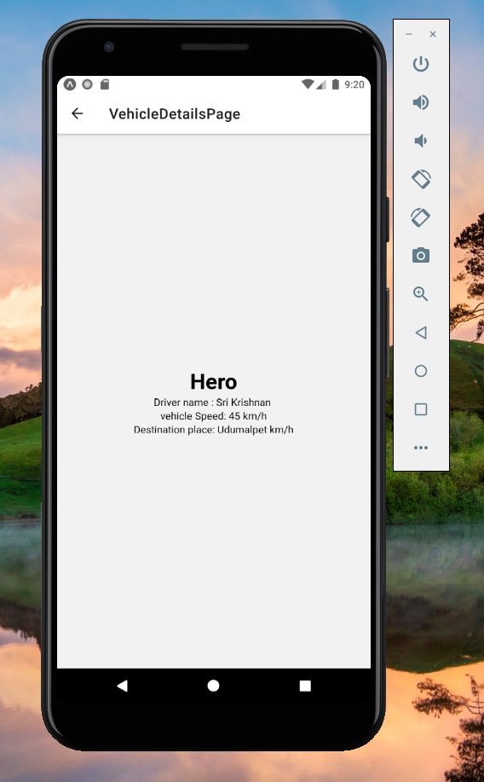

**TRAFFIC INFO**

**Vehicle Details Screen (VehicleDetailsPage.js):**

* Objective: Displays information about a vehicle, including its name, driver name, speed, and destination place.
* Technology: Text components for displaying vehicle details.
* Traffic Condition Screen (TrafficConditionPage.js):
* Objective: Intended to display traffic condition information. The implementation for fetching and displaying this data is incomplete.
* Technology: Placeholder text for the "Traffic Condition" title.

The mobile application is a React Native-based platform that serves as a vehicle tracking and monitoring tool, integrating IoT (Internet of Things) technology. The application is suitable for scenarios where real-time vehicle tracking and monitoring are essential, offering users insights into vehicle status and traffic conditions.

**Conclusion:**

In conclusion, the provided mobile application is a robust platform that showcases the integration of IoT technology to enable real-time vehicle tracking and monitoring.By combining React Native for the mobile app's front-end with IoT technology for data collection and analysis, this application illustrates the potential for creating powerful, data-driven tools to improve vehicle management and road safety. The provided code serves as a foundation that can be further expanded and customized to meet the specific needs of different industries and users.